Discrete Mathematical Structures
(Question Bank)

UNIT – III
1 |  | Write the rules for constructing Hamiltonian paths and cycles. | L3 | CO3 | [6M]
2 |  | Explain about Walk and types of walk with suitable example | L2 | CO3 | [6M]
3 |  | Write the difference between Hamiltonian graphs and Euler graphs. | L3 | CO3 | [6M]
4 |  | Explain about Isomorphism graphs with suitable example. | L2 | CO3 | [6M]
5 |  | Write short notes on Trail, Path, Cycle with an example | L3 | CO3 | [6M]
6 |  | Explain about Euler Graphs with an example | L2 | CO3 | [6M]
7 |  | Explain about Hamiltonian Graphs with an example

UNIT – IV
1 |  | Explain Kruskal’s algorithm to find minimal spanning tree of the graph with suitable example | L2 | CO4 | [12M]
2 |  | Explain Prim’s algorithm to find minimal spanning tree of the graph with suitable example | L2 | CO4 | [12M]
3 | a) | Explain planar graph with suitable example. | L2 | CO4 | [6M]
3 | b) | Write a short notes on graph colouring with an example | L2 | CO4 | [6M]
4 |  | Explain depth-first search and breadth-first search to find the spanning tree with suitable examples | L2 | CO4 | [12M]
5 | a) | Find Minimum spanning tree for a graph in Fig below using Kruskal’s algorithm.  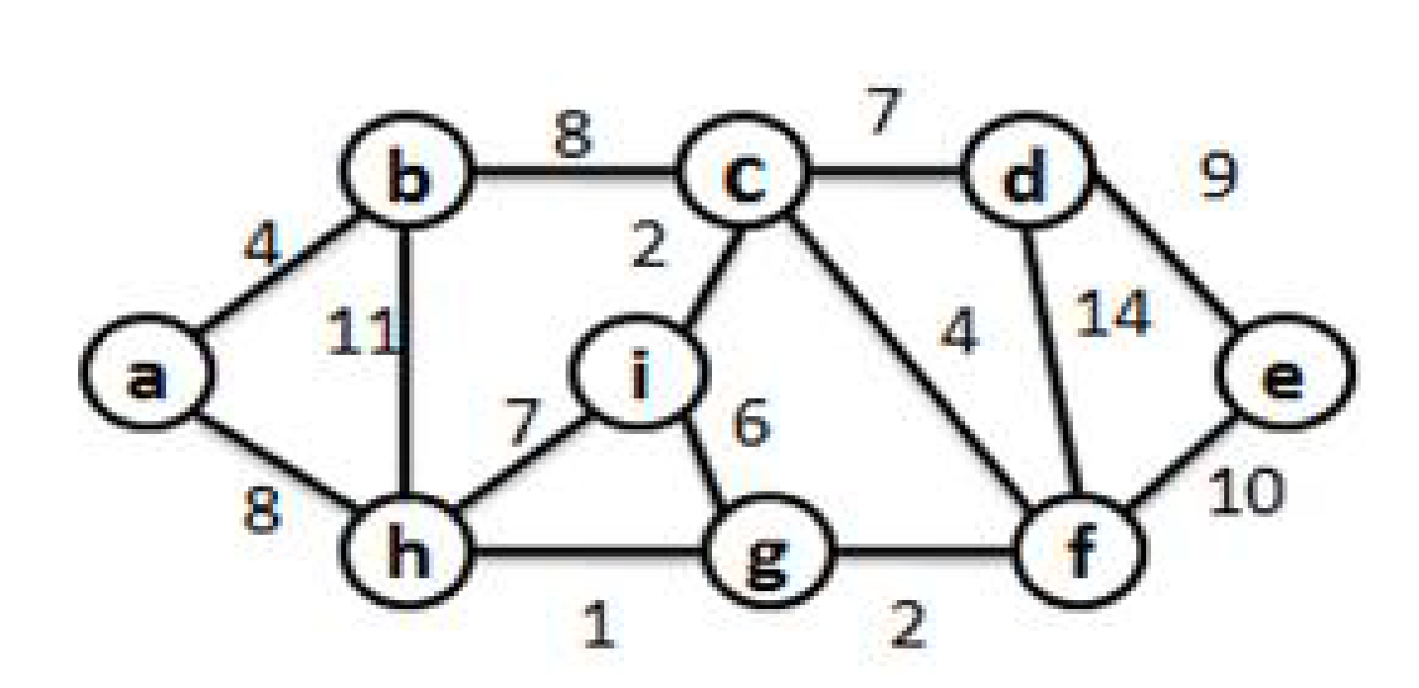 | L2 | CO4 | [6M]
5 | b) | Show that the complete graph with 5 vertices is non planar? | L2 | CO4 | [6M]
6 | a) | Write a short notes on chromatic number with suitable example | L | CO4 | [6M]
6 | b) | With suitable examples, explain the terms Tree, Spanning tree. | L2 | CO4 | [6M]
8 |  | Using Prim’s algorithm, find a minimal spanning tree for the weighted graph shown below:  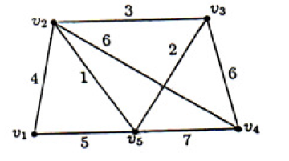 | L2 | CO4 | [6M]
8 | b) | With suitable examples, explain the terms Tree, Spanning tree. | L2 | CO4 | [6M]
9 | a) | Write the Kruskal’s algorithm and find minimal spanning tree of the weighted graph shown below  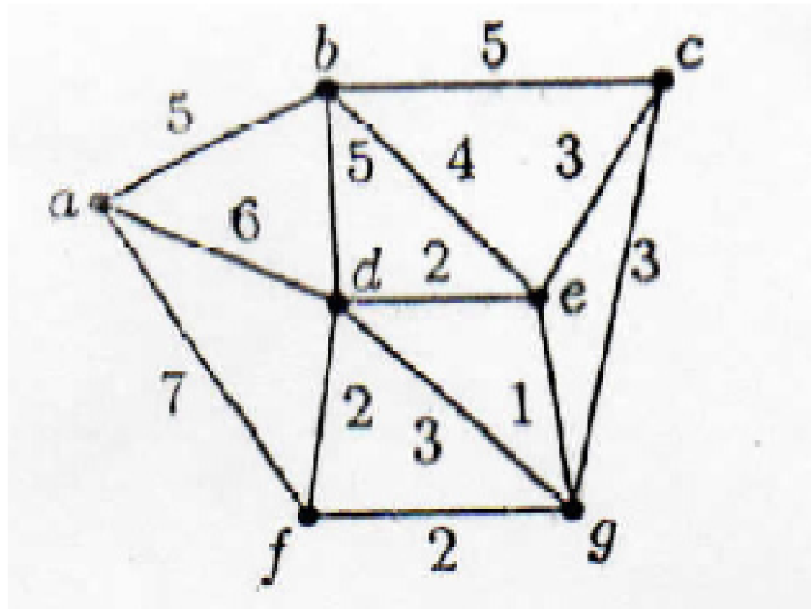 | L3 | CO4 | [6M]
9 | b) | Show that the complete graph with 5 vertices is non planar? | L2 | CO4 | [6M]

UNIT – V
1 | a) | Solve a_{n} = a_{n-1} + f (n) for n>= 1 by substitution. | L3 | CO5 | [6M]
1 | b) | Solve a_{n} = a_{n-1} + 2a_{n-2}, initial conditions a₀ = 0, a₁ = 1. | L3 | CO5 | [6M]
2 | a) | Solve the recurrence relation of Fibonacci sequence of numbers f_{n}=f_{n-1}+f_{n-2 ,}n>=2 where initial conditions f₀=0,f₁=1 | L3 | CO5 | [6M]
2 | b) | What is recurrence relation? Find first five terms of sequence a_{n} = a²_{n-1} ,a1=2 | L1 | CO5 | [6M]
3 | a) | Solve a_{n} = 8a_{n-1} - 16a_{n-2}, initial conditions a₀ = 16, a₁ = 80. | L3 | CO5 | [6M]
3 | b) | Solve a_{n} = a_{n-1} + f (n) for n>= 1 by substitution. | L3 | CO5 | [6M]
4 | a) | Use generating functions to solve the recurrence relation a_{n}=3a_{n-1}+2, n>=1 with a₀=1 | L3 | CO5 | [6M]
 | b) | What is recurrence relation? Find first five terms of sequence a_{n} =na_{n-1} + n²a_{n-2}, a₀=1, a₁=1 | L1 | CO5 | [6M]
5 | a) | What is recurrence relation? Solve a_{n}=a_{n-1} +n where a₀=1 by substitution. | L1 | CO5 | [6M]
 | b) | What is recurrence relation? Find first five terms of sequence a_{n} = a²_{n-1} ,a1=2 | L3 | CO5 | [6M]
6 | a) | Let a_{n} = na_{n-1} +n² a_{n-2} where a₀ =1,a₁ =1. find a₂ ,a₃ ,a₄ ,a₅ | L3 | CO5 | [6M]
 | b) | What is recurrence relation? Solve a_{n}=a_{n-1} +n where a₀=1 by substitution. | L1 | CO5 | [6M]
7 | a) | What is recurrence relation? Find first five terms of sequence a_{n} =na_{n-1} + n²a_{n-2}, a0=1, a1=1 | L1 | CO5 | [6M]
 | b) | Solve the recurrence relation of Fibonacci sequence of numbers f_{n}=f_{n-1}+f_{n-2 ,}n>=2 where initial conditions f₀=0,f₁=1 | L3 | CO5 | [6M]
8 | a) | Use generating functions to solve the recurrence relation a_{n}=3a_{n-1}+2, n>=1 with a₀=1 | L3 | CO5 | [6M]
 | b) | Solve a_{n} = a_{n-1} + f (n) for n>= 1 by substitution. | L3 | CO5 | [6M]
9 |  | What is recurrence relation? Solve a_{n+2} +3 a_{n+1+}2a_{n = 3}^{n} where n>=0, initial condition are a₀=0, a₁=1 | L3 | CO5 | [12M]

